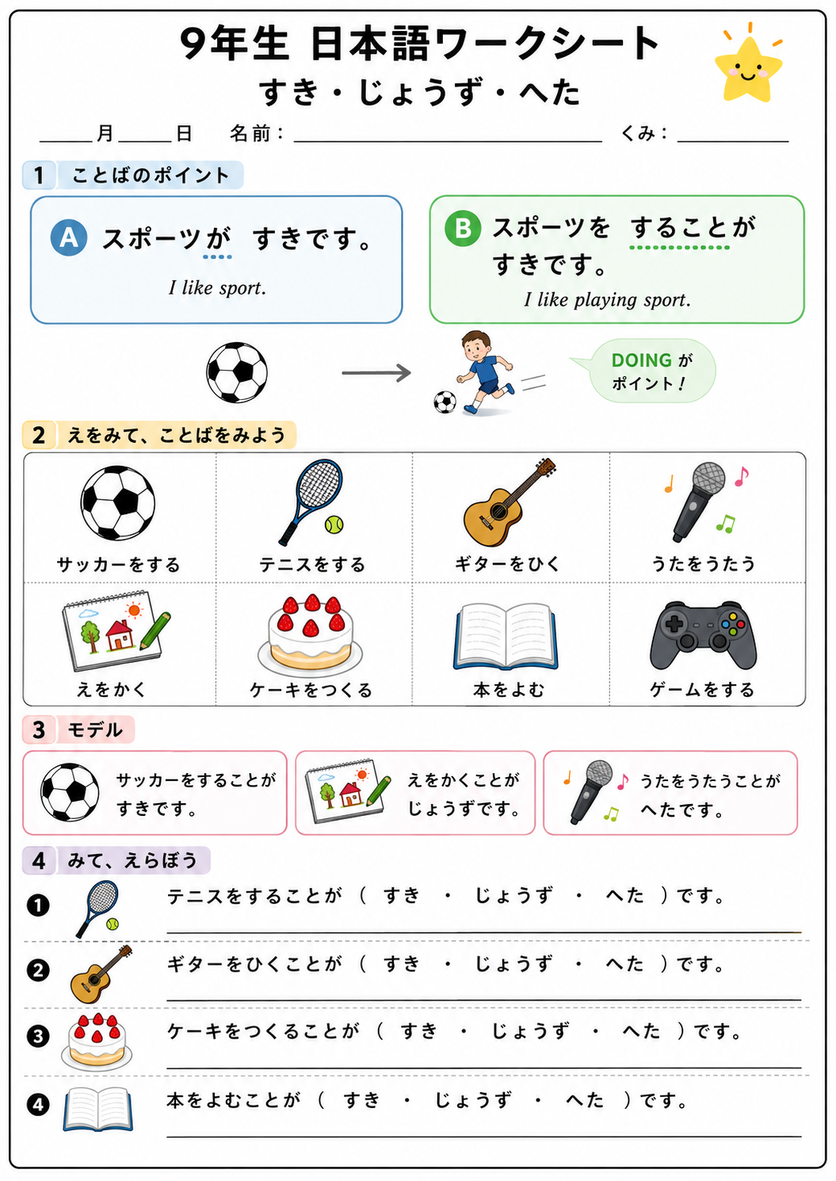
1. Write the Japanese sentence.
- I like playing soccer.

- Mum is good at playing tennis.

- I am not good at singing.

2. Use the prompts to write Japanese.
- games / play / like

- Friend / guitar / play / good at

- cake / make / not good at

3. Write 2 sentences about yourself.
- わたしは…___________________________________________________________________________
- わたしは…___________________________________________________________________________
4. チャレンジ (Extension challenge)
Write one sentence about another person.
ともだちは___________________________________________________________________________________
父・母は_____________________________________________________________________________________

